**EWCTI2018 – Associated Institutes & Organizations**

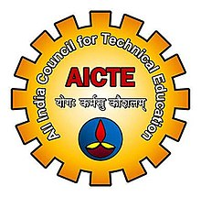

**All India Council for Technical Education (AICTE)**



**Association of Indian Universities (AIU)**



**Telangana State Council of Higher Education (TSCHE)**



**Andhra Pradesh State Council of Higher Education (APSCHE)**

**All India Council for Technical Education (AICTE)**

All India Council for Technical Education (AICTE) was set up in November 1945 as a national-level apex advisory body to conduct a survey on the facilities available for technical education and to promote development in the country in a coordinated and integrated manner. And to ensure the same, as stipulated in the National Policy of Education (1986), AICTE was vested with:

* Statutory authority for planning, formulation, and maintenance of norms & standards
* Quality assurance through accreditation
* Funding in priority areas, monitoring, and evaluation
* Maintaining parity of certification & awards
* The management of technical education in the country

**More details at:** [**https://www.aicte-india.org/**](https://www.aicte-india.org/)

**Association of Indian Universities (AIU)**

The idea of bringing together all the universities on a common platform emerged from the deliberations of a Conference of the Vice Chancellors of Universities convened by Lord Reading, the then Viceroy of India at Shimla in 1924. The Inter-University Board (IUB) of India was subsequently formed on March 23, 1925, with the view of promoting university activities, especially by way of sharing information and co-operation in the field of education, culture, sports and allied areas. The Inter-University Board acquired a legal status with its registration in 1967 as a Society under the Societies Registration Act, 1860. In 1973, it assumed its present name: The Association of Indian Universities (AIU). The membership includes traditional universities, open universities, professional universities, Institutes of National Importance and deemed-to-be universities. In addition, there is a provision of granting of Associate Membership to universities of neighboring countries.

**More details at:** [www.aiu.ac.in/](http://www.aiu.ac.in/)

**Telangana State Council of Higher Education (TSCHE)**

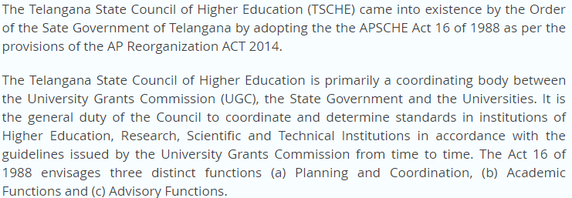

**More details at:** <https://www.tsche.ac.in/>

**Andhra Pradesh State Council of Higher Education (APSCHE)**

The A P State Council of Higher Education (APSCHE) came into existence w.e.f. 20.05.1988 through Act 16 of 1988 to advise the Government in matters relating to Higher Education in the State and to oversee its development with perspective planning and for matters connected therewith and incidental thereto.

The Andhra Pradesh State Council of Higher Education, the first of its kind in the country, set up as per the recommendations of the National Education Policy 1986, is primarily a coordinating body between the University Grants Commission (UGC), the State Government and the Universities. It is the general duty of the Council to coordinate and determine standards in institutions of Higher Education, Research, Scientific and Technical Institutions in accordance with the guidelines issued by the University Grants Commission from time to time. The Act 16 of 1988 envisages three distinct functions (a) Planning and Coordination, (b) Academic Functions and (c) Advisory Functions.

**More details at:** [**http://www.apsche.org/apsche_new/**](http://www.apsche.org/apsche_new/)